SUMMERVILLE CREDIT UNION · CONSOLIDATED MEMBER GUIDE · CSUM-19 of 30
Alerts & Notifications

Module: nFinia Digital Banking > Settings > Alerts
Sources: Summerville Reports Series A (36 docs) + Series B (25 docs) | Features: nFinia Documentation Features Spreadsheet
01 PRODUCT SUMMARY

The Alerts & Notifications module allows members to configure real-time account alerts delivered via push notification, SMS, or email. Members receive immediate notification of account events that matter to them — low balance warnings, large transactions, successful transfers, payment postings, security events, and new eDocument availability — without needing to log in and check manually.
Members can set general alerts that apply system-wide (login notifications, security events) as well as account-specific alerts configured per account (balance threshold, individual transaction amount triggers). The Do Not Disturb schedule mutes non-critical notifications during specified hours while maintaining delivery of critical security alerts.
Alert history is maintained in the Inbox, giving members a retrospective view of all alerts they have received. The Scheduled/Recurring Transfer Alerts feature specifically notifies members before and after scheduled transfers execute, providing visibility into automated payment activity.

At a Glance

Attribute | Detail
Module | Settings > Alerts
Alert Types | Balance, Transaction, Security, Login, Payment Posted, eDocument Available
Delivery Channels | Push Notification, SMS, Email
Account-Specific | Balance threshold and large transaction alerts per account
Do Not Disturb | Time-window to mute non-critical alerts
Related Reports | CSUM-24 (Message Center), CSUM-25 (Settings & Security)

02 KEY USE CASES

Use Case | Who Uses It | What They Do | Business Value
Low Balance Alert | Members monitoring overdraft risk | Set balance alert threshold per account | Early warning before overdraft to fund account in time
Large Transaction Alert | Members detecting fraud | Configure alert for charges above a set dollar amount | Immediate notification of unexpected large transactions
Login Notification | Security-conscious members | Enable login alert for all new sign-in events | Real-time detection of unauthorized login attempts
Do Not Disturb Schedule | Members avoiding overnight alerts | Set DND hours to mute non-critical notifications | Reduces sleep disruption while maintaining critical security coverage

03 STEP-BY-STEP GUIDE

Navigation: Dashboard > Settings (gear icon) > 'Alerts' OR More > Settings > Alerts.

Step 1 — Start from Dashboard
The member begins at the Dashboard after logging in. The Dashboard displays all account balances, upcoming payments, quick-action tiles, and the top navigation bar with links to Accounts, Move Money, and More.
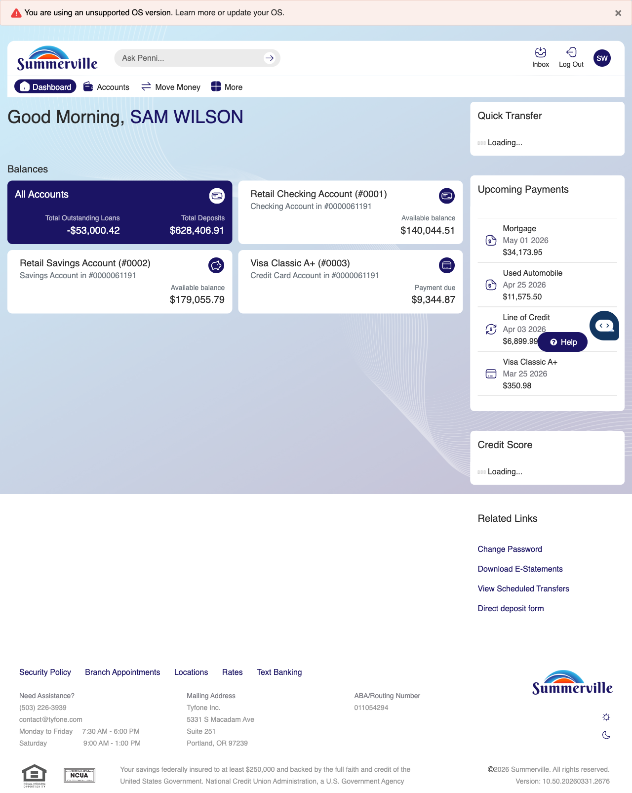
Step 1: Start from Dashboard

Step 2 — Open the More Menu
The member clicks ‘More’ in the top navigation bar. The More options panel expands to show additional features: Check Deposit, User ID and Password, eDocuments, Account Alerts, General Alerts, Password, Forms, One-Time Passcode, Skip A Pay, Do-Not-Disturb, Manage Devices, My Insights, Alert Settings, Recent Activities, and Card Services.
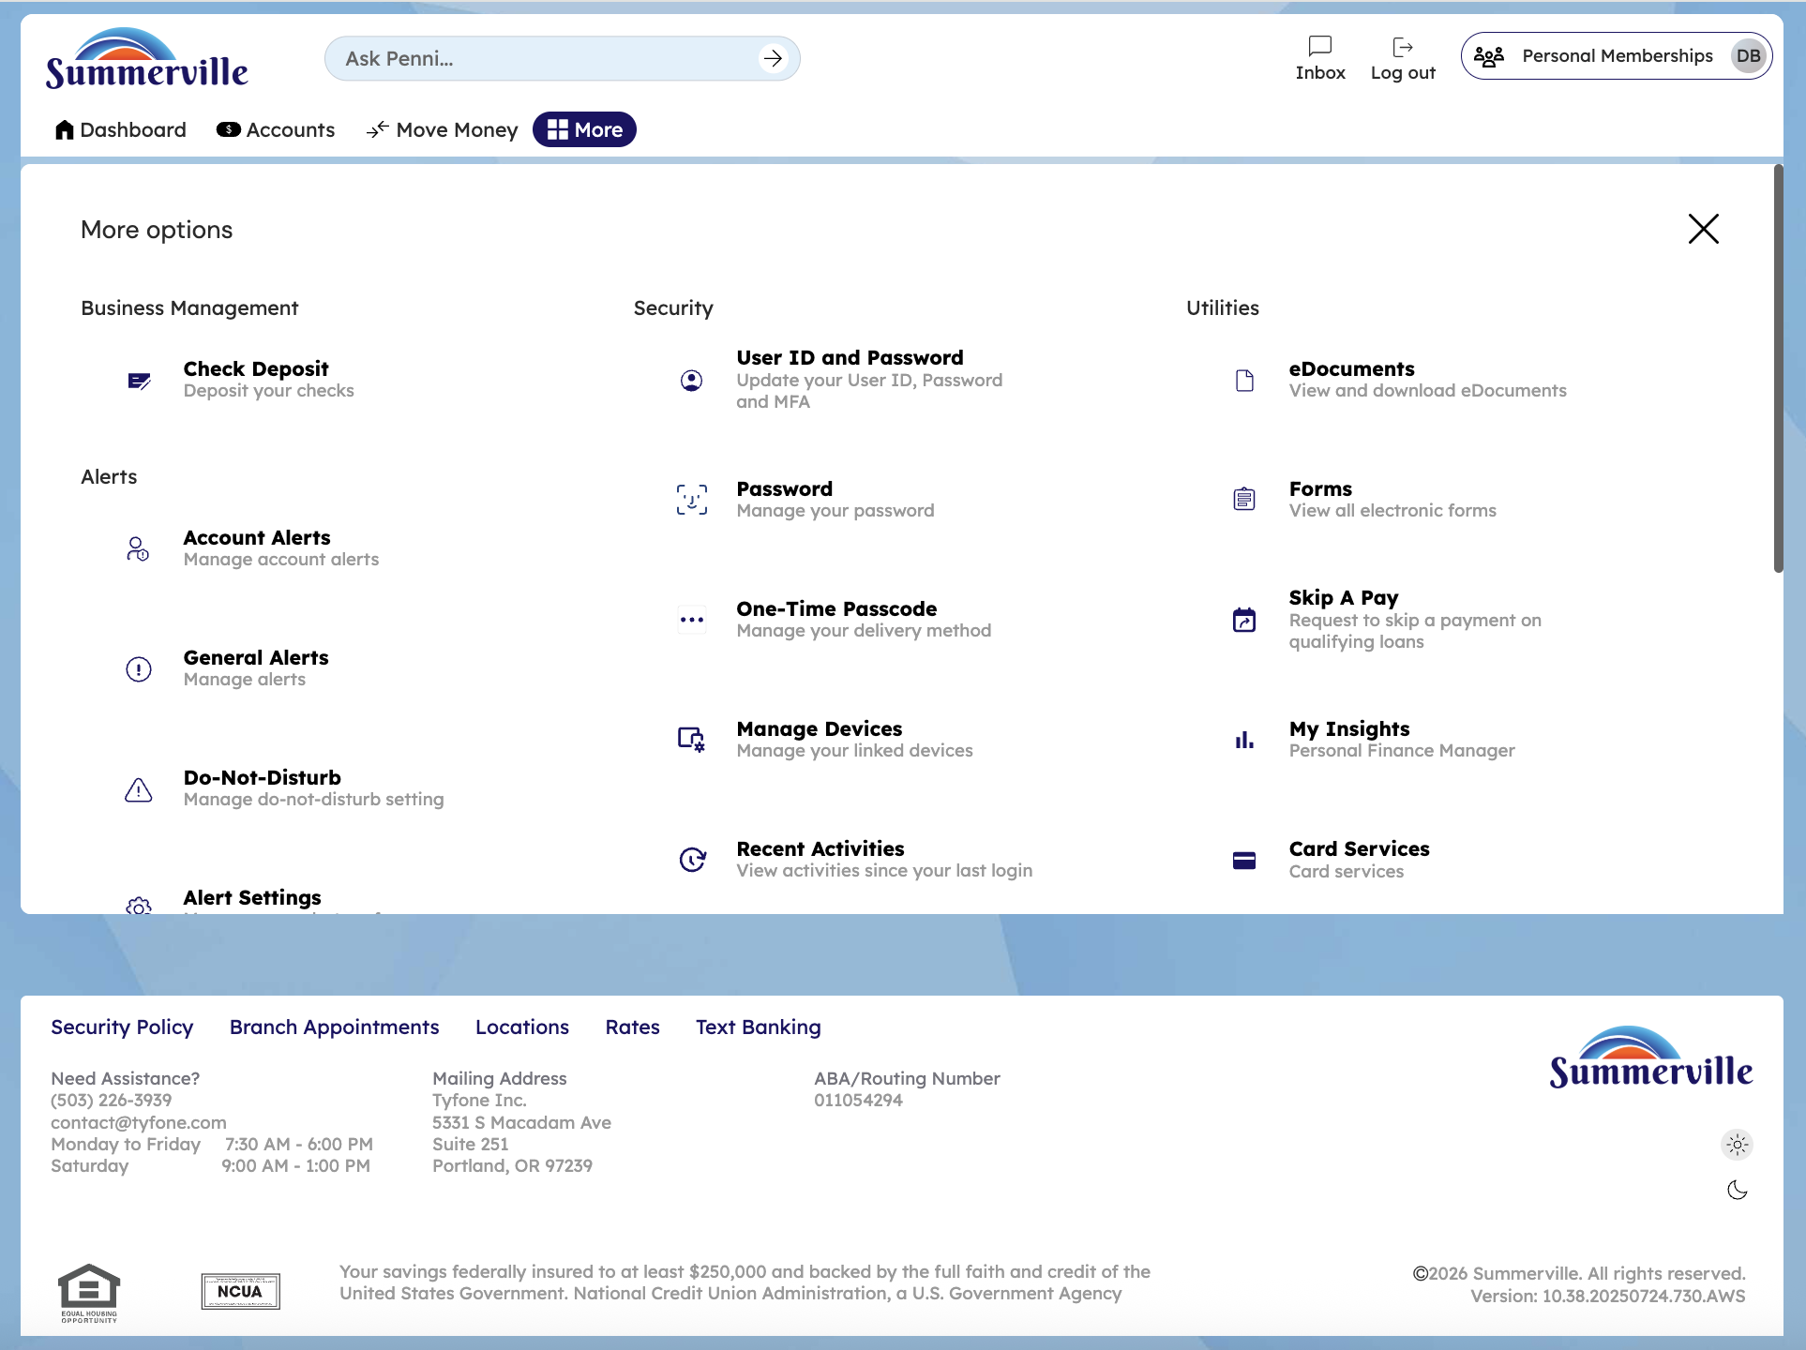
Step 2: More Menu

Step 3 — Navigate from Dashboard to Alerts
The Alert Settings page is displayed with tabs for General alerts, Account-specific alerts, Alert Settings, and Do-Not-Disturb. The current view shows alert category options available for configuration.
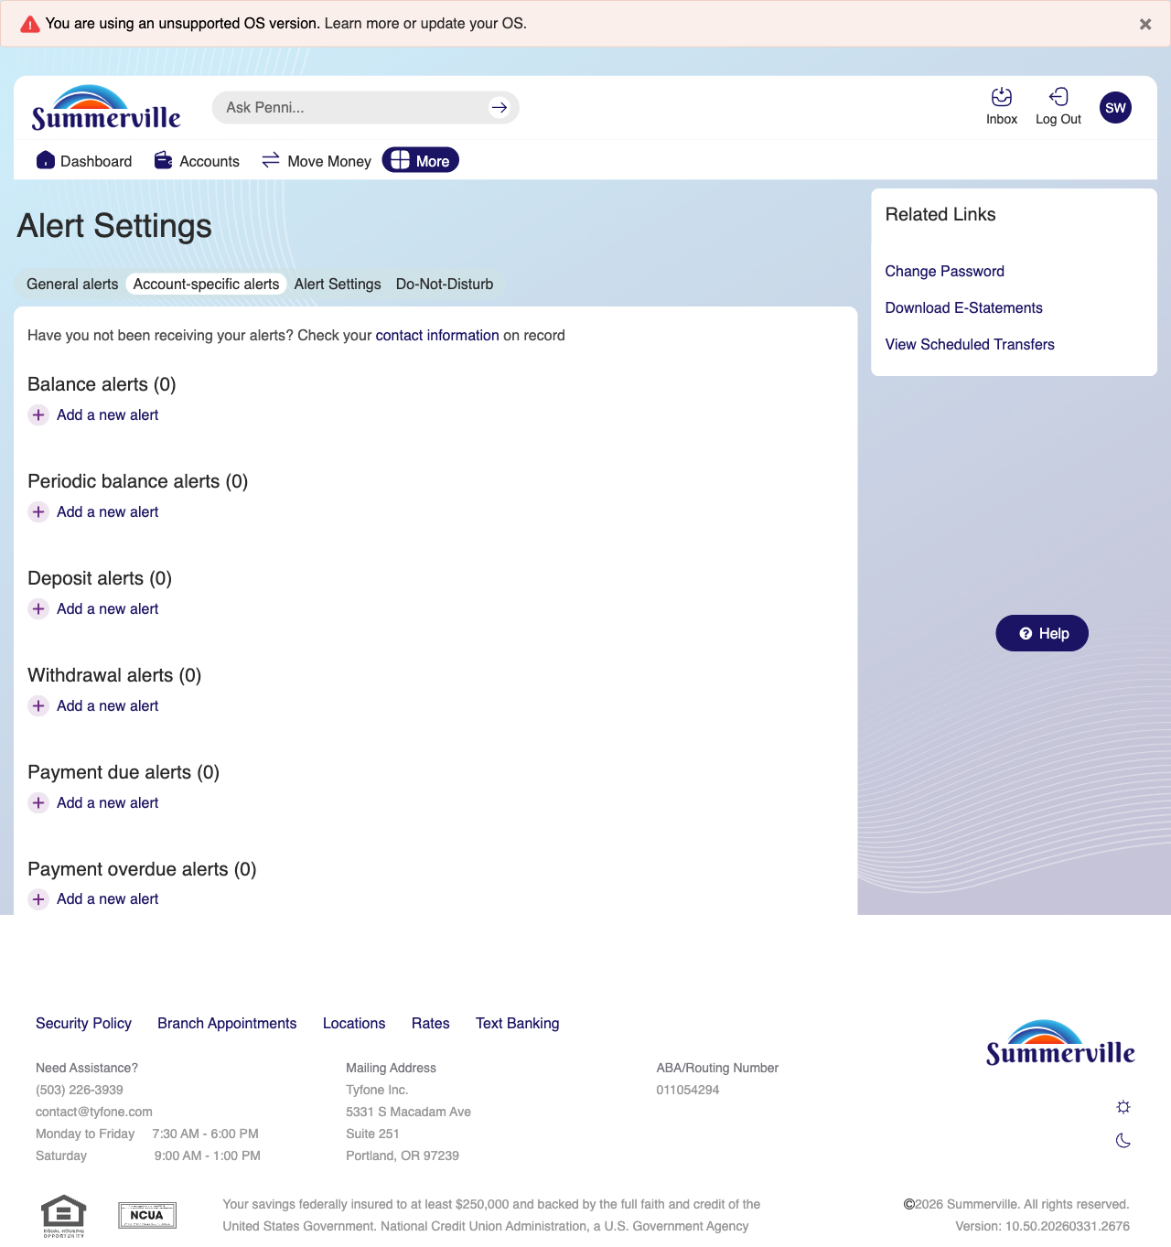
Step 3: Navigate from Dashboard to Alerts

Step 4 — Configure General Alert Settings
The Alert Settings General tab shows alert delivery channel options including toggles for enabling or disabling push notifications and SMS alerts.
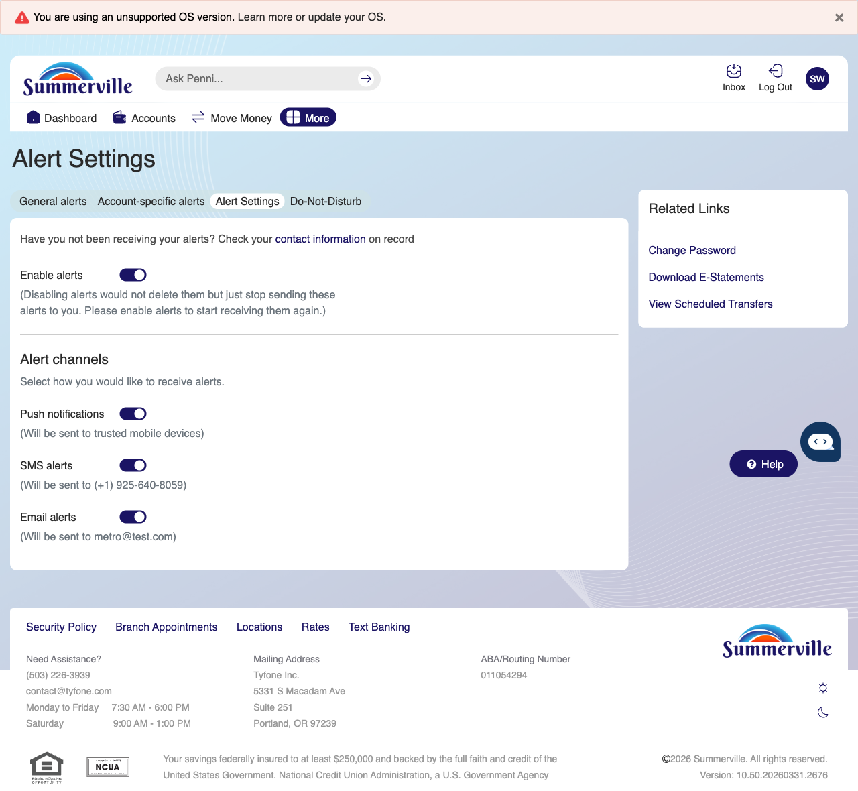
Step 4: Configure General Alert Settings

Step 5 — Configure Account-Level Alert Settings
The Alert Settings Account tab is displayed with a modal dialog open for adding a new available balance alert, showing account selection and threshold amount fields.
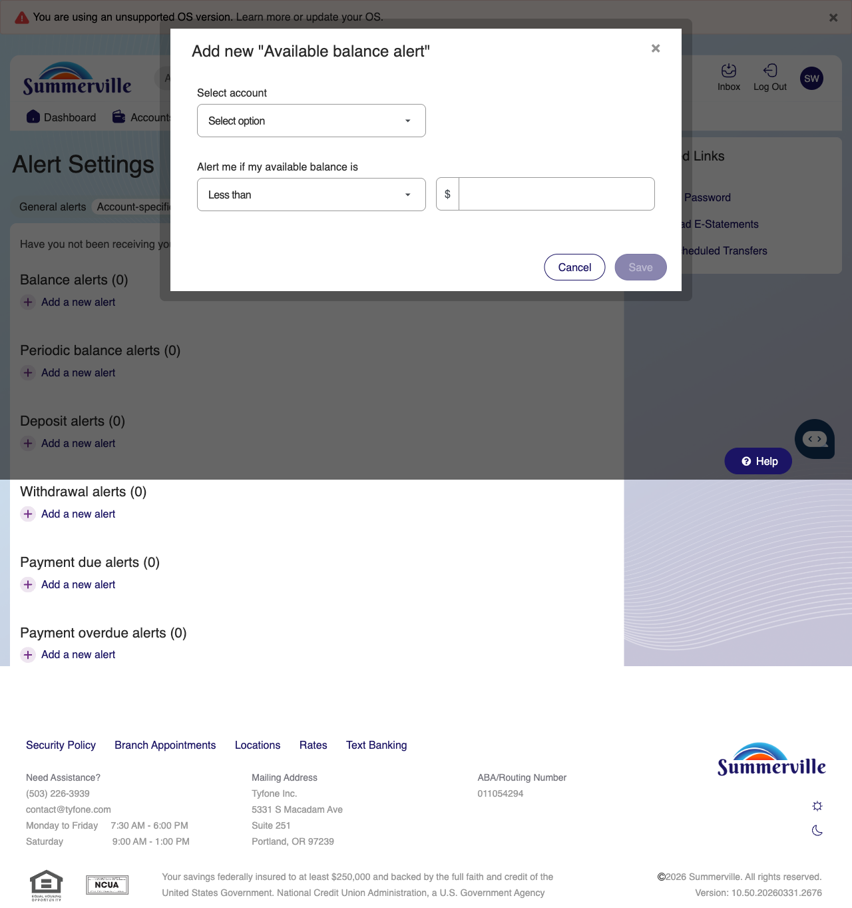
Step 5: Configure Account-Level Alert Settings

Step 6 — Set Do Not Disturb Hours
The Do-Not-Disturb settings page is shown with options to configure quiet hours during which all alert notifications will be suppressed.
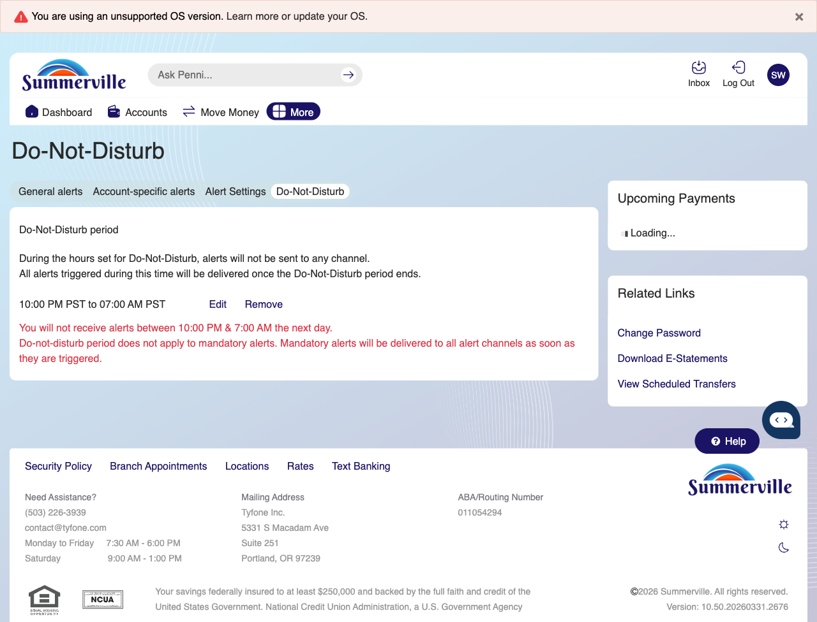
Step 6: Set Do Not Disturb Hours

Step 7 — Review Active Balance Alerts
The Account Specific Alerts section displays options for adding different alert types including balance alerts, periodic alerts, deposit alerts, withdrawal alerts, and payment alerts.

Step 7: Review Active Balance Alerts

Step 8 — Add a Balance Alert
A modal dialog for adding a new available balance alert is displayed with a dropdown to select the account and a text field to set the alert threshold amount.

Step 8: Add a Balance Alert

